Safe Space Inc.

Domestic Violence and Sexual Assault Program

Are you in an abusive relationship or know someone who is?
Maybe you are the survivor of sexual assault.
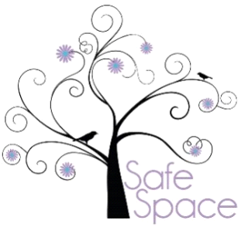
Safe Space can help.
Safe Space provides assistance to primary and secondary survivors of domestic violence and sexual assault, with the goal of breaking the inter-generational cycle of violence.
P.O, Box 594
Butte, MT 59703

Office Line: 406-782-9807
Crisis Line: 406-782-8511
Website: safespaceonline.org
Facebook: safespaceinc
Instagram: safespacebutte
Email: safespaceadvocates@gmail.com
Safe Space Offers:
- 24-Hour Emergency Hotline
- 24-Hour Emergency Advocacy & Support Including On-Scene Response
- Emergency Shelter
- Emergency Transportation
- Emergency Food and Clothing
- Emergency 911 Cell Phones
- Weekly Support Groups
- Counseling Services
- Community Education
*All services are available to both men and women and are provided FREE of charge.
Safe Space Crisis
406-782-8511
Safe Space Crisis
406-782-8511
Safe Space Crisis
406-782-8511
Safe Space Crisis
406-782-8511
Safe Space Crisis
406-782-8511
Safe Space Crisis
406-782-8511
Safe Space Crisis
406-782-8511
Safe Space Crisis
406-782-8511
Safe Space Crisis
406-782-8511
Safe Space Crisis
406-782-8511
Safe Space Crisis
406-782-8511
Safe Space Crisis
406-782-8511
Safe Space Crisis
406-782-8511
Safe Space Crisis
406-782-8511
Safe Space Crisis
406-782-8511

