Oct.-Dec. 2023 | Safe Space | (406)782-9807  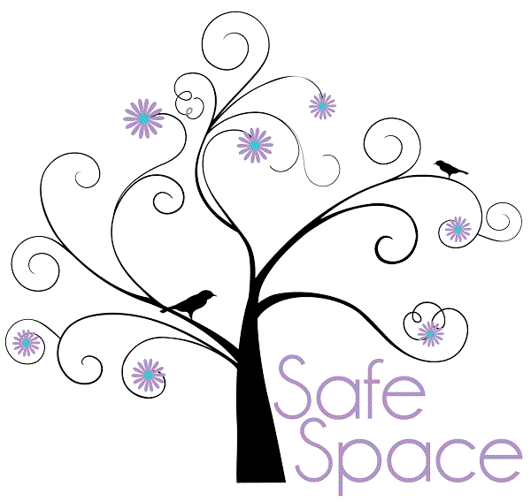  1  CRISIS LINE AVAILABLE 24/7  (406)782-8511 | Contents  New Executive Director 1  Support Groups 2  Services/Areas Provided 2  Officer of the Year Award 3  Quarterly/Yearly Statistics 4  Donations/Donors 5  Volunteers/Volunteering 5  Introductions and Special Thanks 6  Sexual Assault Groups 6  Future Events 7  Safe Space Staff and Board 8  Contacts 9
Safe Space Quarterly

Welcome and Meet Our New Executive Director!

It was very hard to say good-bye to our Interim Executive Director, Tonya Geraghty, but Safe Space is proud to announce that we have an Executive Director that came from within! Our new Executive Director, Rachael Weaver. joined us in March of 2022 as our Shelter Manager. In July of 2023, Tonya Geraghty passed the torch and Rachael became our Executive Director.

Rachael spent a decade working with troubled youth and had to shift her career path unexpectedly. After only a short period of time it was clear she was already dedicated to our program. With our amazing team of Advocates, Rachael has great ideas to push our program farther than it has ever gone.

“I have big shoes to fill. I am excited to see the program succeed in ways never thought of. I wouldn’t be able to do this without the help of this great team of advocates, the dedicated board members, and the guidance/mentoring/support that Tonya has given me. Thank you for this opportunity!”

More information about Rachael will be available on our website, soon!

Congratulations Rachael!

Weekly Support Groups  Safe Space offers a free, weekly support group to its  clients. Domestic Violence groups are every Tuesday from 5:00 pm to 6:00 pm, and are led by our Support Group Facilitator, Marci Robinson. Sexual Assault groups are every Friday from 5:00 pm to 6:00 pm, and are coordinated by our sexual assault specialist, Kelly Lewis. Support groups are a great way for clients to have an open and respectful discussion with one another, and freely express their thoughts and feelings.  Children’s group is also available at this time, for those whose parents are attending the support group. During this time, children will participate in a project or activity led by our children’s group Facilitator, Winchester Kessler. |  | 2
Call us today to learn more about our support groups and where they are held!  (406)782-9807 | Don’t be ashamed of your story.  It will inspire others.
Safe Space is Expanding!  We are currently looking to find an office space in the Deer Lodge area!  If you know of some place that may be available and appropriate for our use in the Deer Lodge area please let an advocate know at: (406)782-9807. | Services and Areas Provided
Safe Space provides both residential and non-residential services to clients that have been victimized by domestic violence and/or sexual assault. We serve men, women, and children in Butte Silver-Bow County, as well as five surroundings areas: Granite, Powell, Deer Lodge, and portions of Jefferson and Madison counties. Access to our services has been limited in our other counties but we are looking to expand our non residential services to include an office space in Deer Lodge. We are currently searching for an appropriate office space.
Residentially, Safe Space houses up to 23 clients in shelter. Residents are provided with their own bedroom, clothing, food, and 24/7 advocacy support. Safe Space offices are located directly within the shelter, allowing constant personal contact with the residents.
Clients are able to receive non-residential services as well. These services include providing assistance in obtaining restraining orders, working with Child Protective Services, and advocacy during court hearings.
Safe Space also helps all clients with obtaining affordable housing by working closely with Action, Inc., and providing assistance in receiving benefits through Medicaid and the Supplemental Nutrition Assistance Program (SNAP). Safe Space also helps provide clients with clothing, food, diapers, bedding, furniture, and household supplies, which are generously donated by the community.

2023Officer of the Year Award

3
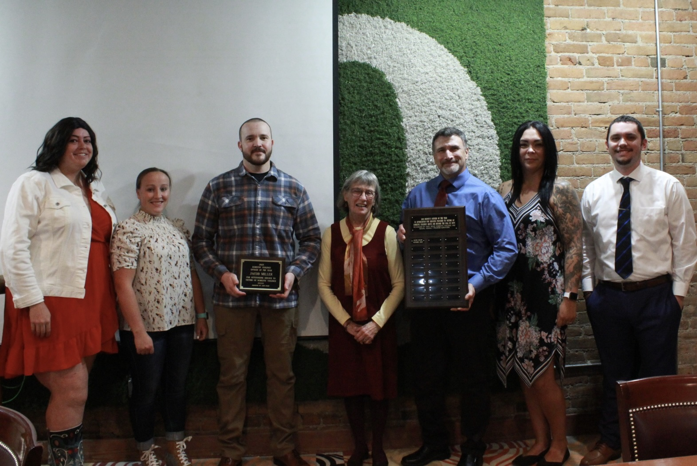

Congratulations, Officer Jacob Miller!

Safe Space would like to thank Officer Jacob Miller for his kind demeanor and quick response to survivors of domestic violence and sexual assault. Our clients chose Officer Miller by completing an evaluation of officers during their response to a crisis. Officer Miller went above and beyond in providing comfort and support to clients during this extremely difficult time.

Thank You, Officer Miller!
Safe Space is proud to have you on the force, and on our side.

Keep up the great work!

Show Me the Numbers!
4
Safe Space Quarterly Statistics
Financial Assistance Material Assistance
October- $3,101.06 October- $3660.25
November- $1,886.77 November- $4942.00
December- $483.21 December- $1937.50

Crisis Calls- Domestic Violence Crisis Calls-Sexual Assault
October - 49 October - 6
November - 38 November - 11
December - 50 December - 9

4th Quarter Total Statistics
Financial Assistance- $3,584.27
Material Assistance- $10,539.75
Sexual Assault Calls- 26
Domestic Violence Calls- 137

Safe Space Yearly Statistics 2023
Financial Assistance- $15,234.81
Material Assistance- $23,628.70
Sexual Assault Crisis Calls- 77
Domestic Violence Crisis Calls- 500
Thank You, Donors and Volunteers!
5
Safe Space would like to thank all of the wonderful donors from the past quarter. Your continued support and assistance makes an enormous difference in our clients lives, and helps them transition from victims to survivors. Thank you for everything that you do! We sincerely apologize if we have forgotten anyone on this list. We greatly appreciate our contributors, as you provide us with the ability to assist those who need our shelter and services.
Donate to Safe Space!
As we are a non-profit agency, Safe Space is always thankful for the donations that we receive. The support and generosity of our community has greatly benefited our clients. A wish list of shelter items is available on our website at www.safespaceonline.org, or you can call us today for more information at (406)782-9807. Thank you for your efforts in assisting survivors of domestic violence and sexual assault.
VOLUNTEERING AT SAFE SPACE

Safe Space is incredibly grateful to all of our volunteers. Your hard work and dedication allows Safe Space to continue working towards happy and healthy homes for all of our clients. We appreciate everything that you do!

Volunteers for Safe Space can help in numerous ways, including:

- Shoveling sidewalks
- Organizing donations
- Answering the crisis line
- General cleaning of the shelter
- Preparing and manning information booths at community events, including those at both Montana Tech campuses
- Assisting staff with presentations
- Do you have any special skills or talents? Do you have something in particular that you would like to do? Just let us know!

Safe Space would like to welcome its new Volunteer Coordinator, Heather Thatcher Welcome to the team!

4th Quarter Donors
Kathleen Martin Bobbie Daily Catherine Shea
Kurt Kruger Michael Provost Mary Wendt
Heidi Kessler Barbra Burns Kurry Mills Hoffman
Peter Cassidy Jan Polich Terry Kilmer
Kelly Packer Gloria Dei Zach Ueland
Violet Dyson Jackie Markovich Karen Budd
Nancy Markovich Kathy Schelin Julie Flemmin
Courtney Coombe Brian Holland GCR Tires
Veterans of Foreign Wars Ace Hardware
Campbell Investment Management

4th Quarter Volunteers

Trevor Scott Belinda Lopez
Candra Robbins Lindsey Jacobson
Pollann Bruner Tonya Geraghty
Finley Gonzales Brooke Johnson

5
6
Introducing Heather!

Hey there! I’m Heather and I am the Volunteer Coordinator for Safe Space in Butte. My job involves reaching out to the community and taking care of the donations that are donated to the shelter and the program run. I love working with survivors because I get to assist them with their needs and a listening ear when they need to talk. I’m the one you go to if you want to volunteer at the shelter. I am a mother of an amazing daughter and a little dog and cat.
When I feel like I’m failing just keep moving forward.

Introducing Kelly!

Hey hey hey! I’m Kelly and I’m the Sexual Assault Specialist at Safe Space. I became passionately involved with sexual assault survivors while enlisted in the military in 2014-2022. Although the blueprint is different in camo, the victims’ impact is the same, unfortunately, and I’m honored to be back assisting those to conquer their fears. Outside of the shelter, I have two daughters who have chosen me to mommify their unique path in this life. I enjoy diamond paintings, the essence of crystals, and obsessing over the power of the human brain.

Sexual Assault Support Group

Sexual violence affects millions of people each year in the United States, counting every 73 seconds to be exact. Researchers know the numbers underestimate this problem because many cases are unreported. Survivors may be ashamed, embarrassed, or afraid to tell the police, friends, or family about the violence. Victims may also keep quiet because they have been threatened with further harm if they tell anyone or do not think anyone will help them. In all honesty it’s mostly the way society reacts to the rape culture. Sadly, it’s normalized and includes pushing blame on the victim. This is not ok, EVER, no matter how one perceives it. Rape is rape period.
I conduct a sexual assault group every Friday at 5pm and I encourage all primary and secondary survivors to attend. The main goal is to reduce the barriers for those that still feel as if they are alone. All who attend are treated with dignity and respect and possibly transformed through safety, healing, and support. Please contact Safe Space at 406.782.8511 to get the location of group if interested. These are strictly confidential!!!

HUGE THANK YOU
We at Safe Space would like to give a huge shout out to the YMCA and Montana Precision us with Christmas Assistance for our clients, you don’t know how much it meant to them! Montana Resource for the Christmas dinners for our clients and their family, they appreciated it so much! Thank you to the people of Butte who went out and bought the gift for our clients and their children, you gave them a wonderful Christmas. Thank you as well to Ace Hardware for their Ace Ladies Night and all the donations that came from that! Thank you to our volunteers for organizing the gift and being there for our client’s needs. Thank you to our cleaning lady for keeping the shelter clean and making sure our clients have the necessities that they need. You all are amazing!

8
Future Events

Volunteer Advocacy Training

Safe Space provides Volunteer Advocacy Training to those who wish to give
back to the community. This training is scheduled for:

Friday, May 17th - 4:30 PM- 7:30 PM (Snacks Provided!)
Saturday, May 18th - 12:00 PM- 5:00 PM (Snacks Provided)

THIS TRAINING IS FREE OF CHARGE!
CALL US TODAY TO RESERVE YOUR SPOT! (406)782-9807

Are you ready for the Flocking???

7

Our Flamingo Flock is back and this time accompanied with their Flock Mother, Winchester Kessler… Curious? Call the Flamingo Hotline for more info at:

Flamingo Hotline (406) 498 – 2692

Meet Our Team!
8
Safe Space staff works incredibly hard to ensure that each client receives the best assistance possible. Thanks to the staffs hard work and dedication, Safe Space is able to continue providing assistance to survivors of domestic violence and sexual assault.

Safe Space Executive Director- Rachael Taya Weaver
Assistant Director/Children’s Group Facilitator- Winchester Kessler
Shelter Manager – Nadia Crawford
Volunteer Coordinator/Advocate– Heather Thatcher
Sexual Assault Specialist/Advocate – Kelly Lewis
Weekday Night Advocate- Brenda Beardslee
Weekend Night Advocate- Chelsi Thrasher
Relief Advocate – Rylie Gonzalez
Housekeeper – Melody Gottschall
Maintenance – Dan Huerta
Support Group Facilitator- Marci Robinson
Safe Space Board of Directors

Thank you to our amazing board of directors to their commitment to Safe Space. We cannot thank you enough for your dedication to our program!

President- Dan Murphy Gretchen Geller
Vice President- Amy Schulte Ellen Donohue
Secretary- Taylor Sewell Tim Dick
Treasurer- Theresa Renouard Jorey Thatcher
Accountant- Janet Downey Jen Murphy
Safe Space Domestic Violence and Sexual Assault Program

P.O. Box 594
Butte, MT 59703

24-Hour Crisis Line (406)782-8511
Office Line (406)782-9807
Toll Free National Hotline (877)335-8511

E-Mail: safespaceadvocates@gmail.com
Website:
www.safespaceonline.org
Facebook: www.facebook.com/safespaceinc
Instagram:
www.instagram.com/safespacebutte

9

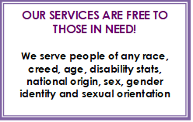

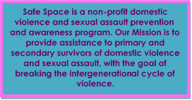

Would you like to receive our quarterly newsletter?

Sign up today on our website, at
www.safespaceonline.org

